Mr Mark Brown 09/12/2021
Alpine Resorts Team,
Department Of Planning, Industry and Environment
PO Box 36,
Jindabyne NSW 2627

Re: DA PAN174813

Dear Mark,
Perisher is submitting additional information for this development application due to the bottom section of the project no longer requiring trenching.
An existing conduit from the race hut above T1 of the Duplex T Bar to the bottom station will be utilised resulting in no excavation works to be carried out with the riparian corridor.
As such can you please update our application to remove the integrated development request.
An updated SEE will be submitted on the planning portal.

If you have any enquiries, please don’t hesitate to contact me.
Regards,

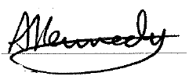

Andrew Kennedy
Mountain Manager
Perisher Blue Pty Ltd
Ph. 02 6459 4504

